Project 2: System Design Document

Rachel Iris Aldava

CS-255

Prof. Christopher Eppenger

August 13, 2023

## UML Diagrams

### UML Use Case Diagram

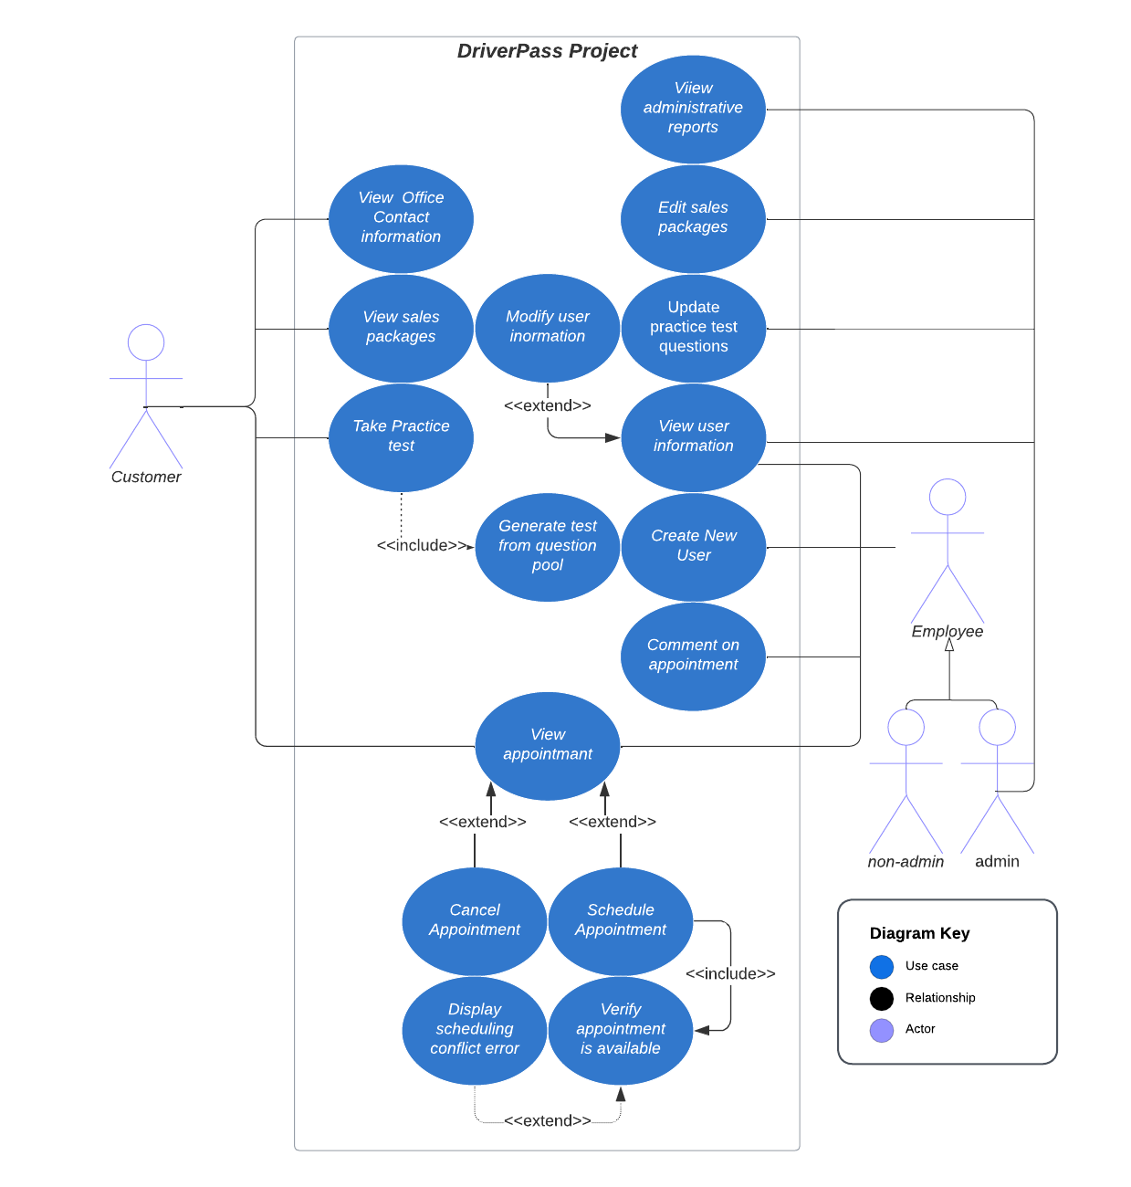

### UML Activity Diagrams

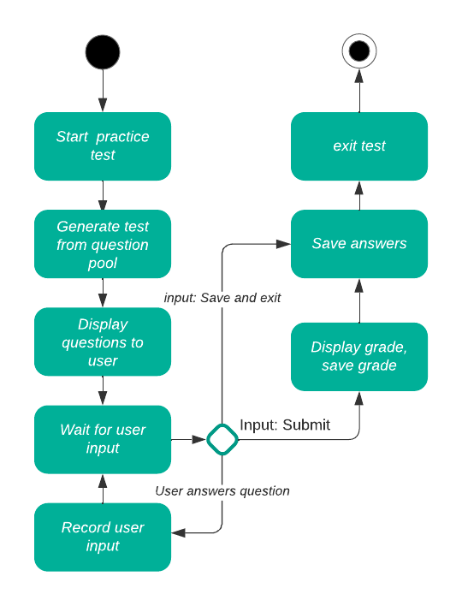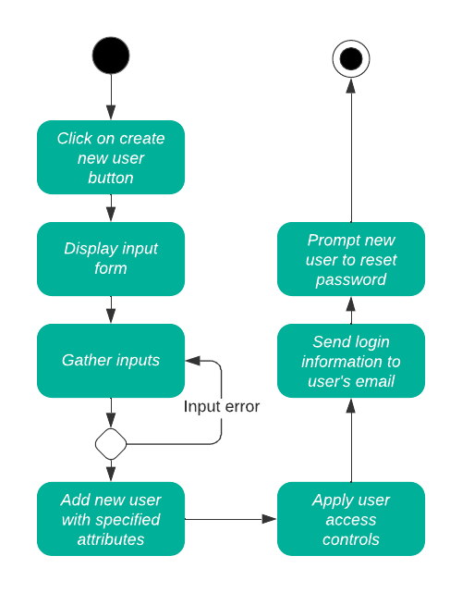

### UML Sequence Diagram

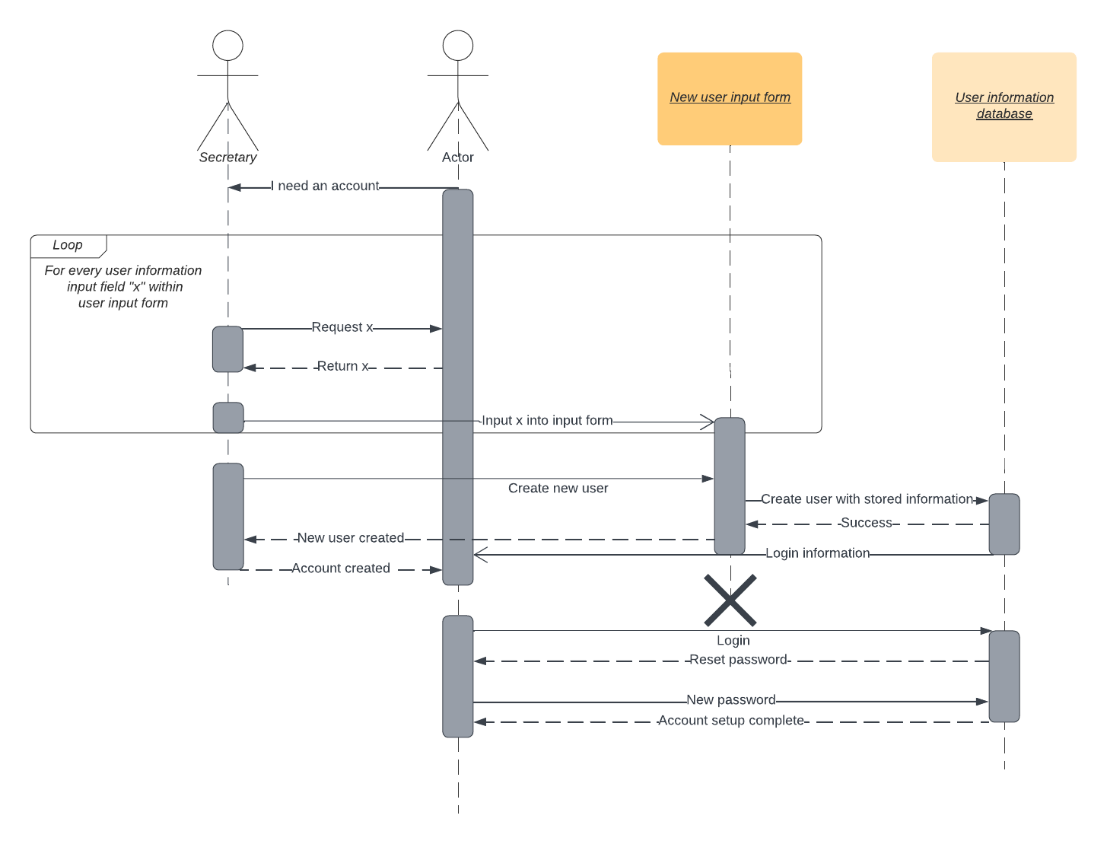

### UML Class Diagram

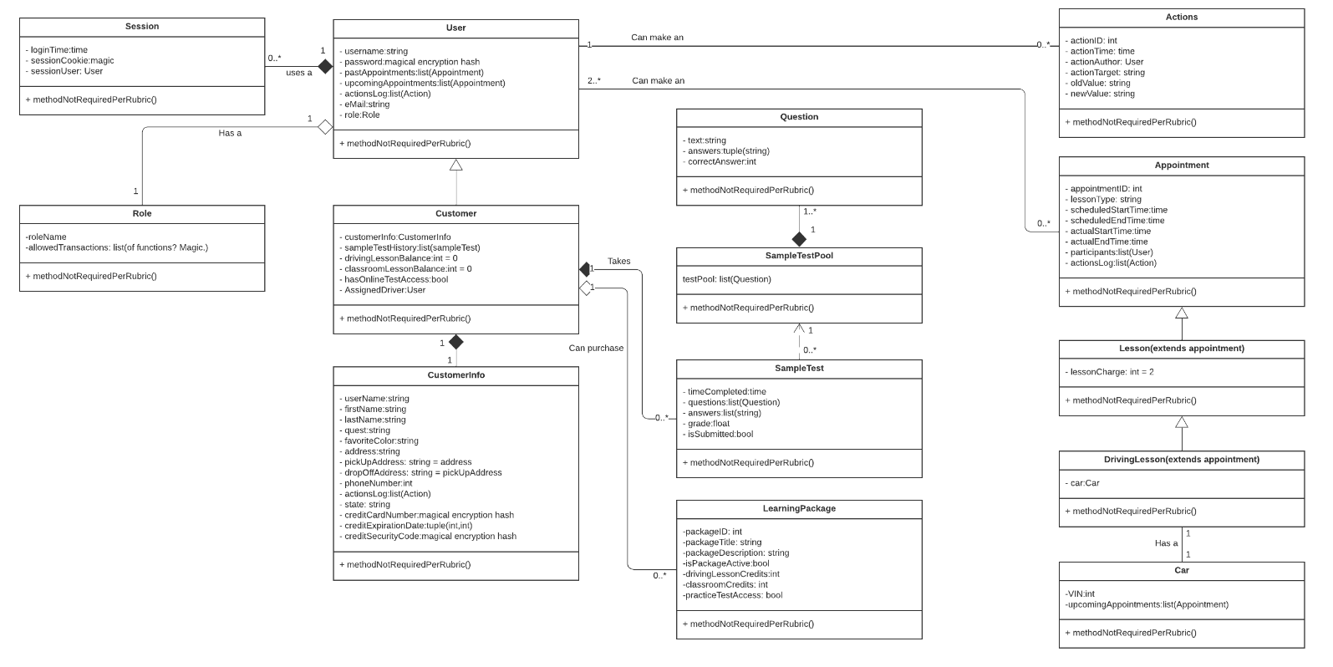

## Technical Requirements

**Development Language:**

Up to this point, my career as a **[third year CS student]** has dealt with backend development. As such my evaluation for what this front-end project needs may be limited. However, from what I have seen of JavaScript, it should enable the development of interactive web pages which can interface with a database. This database will use MySQL. Between JavaScript and MySQL, I do not believe any additional languages will be needed. App development will not be an immediate project; mobile users will be capable of using a small-screen-optimized version of the web page through their browser.

**Software:**

The webserver will run Red Hat Linux, will host the JavaScript web pages, and will house the MySQL database. Merlin, our security specialist, will be installing proprietary encryption, firewall, and antivirus programs which he personally developed prior to the project. If the webhosting service does not provide a method to interface with the server’s terminal, there will need to be a secure method for the administrators to gain access to the server. JavaScript will need to have plugins that allow users to create new sign-on sessions, allow the webpages to generate .xls filetypes, and interface with the MySQL database.

The system will accept HTTPS traffic from clients who use web browsers of Firefox, Safari, Chrome, and Microsoft Edge and support these browsers for Windows, MacOS, Linux (Ubuntu), Android, IOS, and postmarketOS, versions. Our client has indicated that they wish to be able to download reports in the form of spreadsheets, so we should ensure that our client has a copy of spreadsheet software.

**Hardware:**

The client has indicated that the system will be housed in a cloud computing environment. While such operating platforms do have physical characteristics, they are largely abstracted from our considerations. The server will have storage capabilities of at least 8gb, 64gb RAM and at least 1 tb of monthly bandwidth. Users will interface with the system from various devices including traditional personal computers, tablet devices, and mobile devices. Because phone calls play a critical role in several areas of the system including sales and account creation, the office phone could also be considered part of the hardware. While most phones will be adequate, we suggest that the body of the phone will be purple ABS plastic and have sparkles. We also suggest the ringtone of this phone be a klaxon horn.

**Infrastructure:**

The office must house at least one computer which is capable of accessing the internet. We recommend four such terminals in the office. Equipping drivers with data-enabled tablets is encouraged but not required. The office must also house the aforementioned telephone and ensure it is able to receive phone calls. Voicemail capabilities are desirable, but not necessary.